GREENHILL ACADEMY

PRIMARY THREE
LITERACY II LESSON NOTES
FOR
TERM 11(2016)

COMPILED BY;
- ALEX MUTOTO
- ROBERTSON WANZU
- BETTY AKELLO
- ISAAC BUYUNGO
- FLORENCE NAMAGEMBE

WEEK:2
Lesson 1&2

LIVING THINGS IN OUR SUB COUNTY

- There are two main groups of living things namely;
- Plants
- Animals

ANIMALS
2. Animals are grouped into two types;-
- Domestic animals
- Wild animals

Domestic animals
3. What are domestic animals?
These are animals kept at home.

4. Examples;

- cows
- goats
- pigs
- dogs
- cats
- donkeys
- camels
- oxen
- horses
- sheep

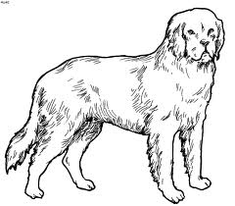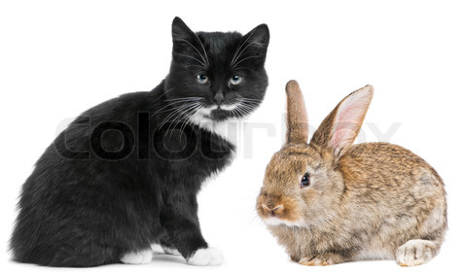
dog cat rabbit
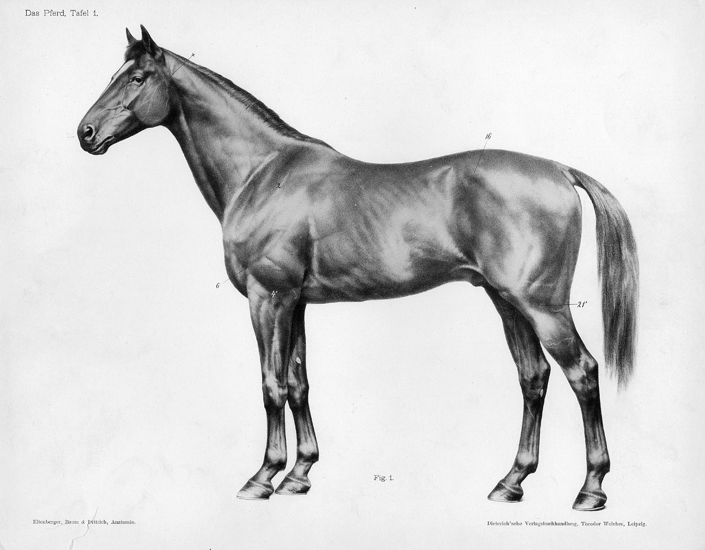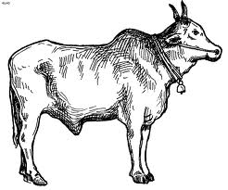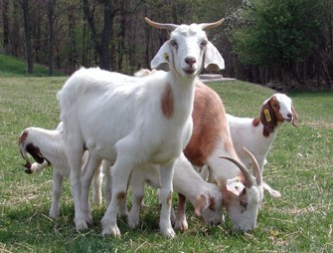
horse cow goats

5. Uses of domestic animals

 | Animals | uses
1 | Cows | - For milk, hides, and skins, horns, beef, cow dung and manure  - Paying bride price.
2 | Goats | - For milk, meat, dung, source of income and playing bride price
3 | Sheep | - Source of income,  - For mutton and wool  - For cultural purposes like sacrifices.
4 | Dogs | - Protect / guard our homes
5 | Cats | - Chase away rats.  - They are also kept as pets.
6 | Oxen | - for ploughing
7 | Donkeys, camels and horses. | - for transport

Exercise
- Define domestic animals
- Why do people keep these animals in their homes?
- dogs
- camels
- cows

Lesson 3
1. Dangers of domestic animals
- They destroy people’s crops.
- Animal dung makes compounds dirty.
- Animal dung is a breeding area for germs.
- They make a lot of noise in homes.
- They keep vectors like lice and fleas that spread diseases to people.
- Mad /rabid dogs spread rabies to people.

2. Ways of caring for domestic animals:
  - By treating the sick animals.
  - By proper feeding.
  - By providing shelter /habitats.
  - By cleaning their habitats.
  - Being kind to them.
  - By protecting them from predators.

Exercise
- Identify three dangers of domestic animals.
- State any three ways of caring for domestic animals.
- Identify the habitats of these animals.
- cow
- horse
- pig
- horse
- How can dogs be a problem to people?

Lesson 4&5
WILD ANIMALS

1. What are wild animals?
These are animals which live in forests, bushes and in water.

2. Examples of wild animals include the following:

- snakes
- lions
- leopard
- rhinos
- wolves
- giraffes
- baboons
- antelopes
- monkeys
- elephants
- tigers
- hippos
- chimpanzees
- gorillas
- hyenas
- cheetahs
- buffaloes
- crocodiles

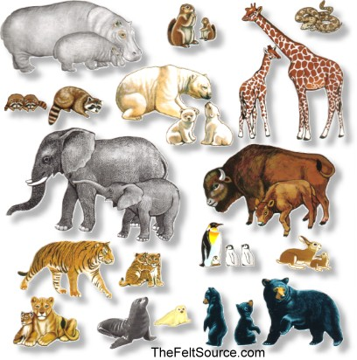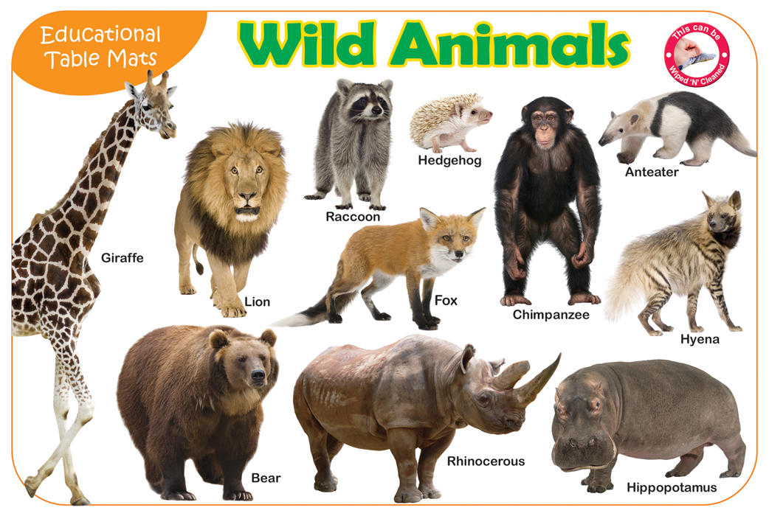

3. Wild animals are kept in special places called game parks, game reserves and zoos.

4. An example of a zoo in Uganda is the wildlife Educational Centre (UWEC) at Entebbe.

5. Examples of game parks include the following;
- Kidepo NP
- Queen Elizabeth NP
- Mt. Rwenzori NP
- Lake Mburo NP

Exercise
- How are wild animals different from domestic animals?
- Write three domestic animals.
- Name one special place where wild animals can be kept.
- Write UWEC in full.

Lesson 6
1. Uses of wild animals.
- They attract tourists.
- Some wild animals provide meat e.g. hippos, antelopes and buffaloes.
- Animals in the zoo are used for study purpose.
- Some wild animals provide skins and hides e.g. snakes, lions, leopards.

2. Who are tourists?
Tourists are visitors from within and outside the country.

NB: These tourists pay money to our country called foreign exchange.

3. Dangers of wild animals
- Some wild animals like squirrels, monkeys, elephants destroy people’s crops.
- Some wild animals like lions kill people and domestic animals.
- Some wild animals spread diseases to people.

Exercise
- Wild animals are very unfriendly. Give two ways how they can be useful to us.
- State two disadvantages of wild animals.
- Who are tourists?

Lesson 7
1. Ways of caring for wild animals:
  - By treating the sick animals.
  - By proper feeding.
  - Protect them from poachers.
  - Be kind to them.
  - Keep them in game parks and zoos.

2. Who are poachers?
Are people who kill wild animals in game parks.

3. What is poaching?
Poaching is the illegal hunting of wild animal in game parks.

4. Things made out of skins and hides

- bags
- belts
- shoes
- drums
- some clothes
- wallets

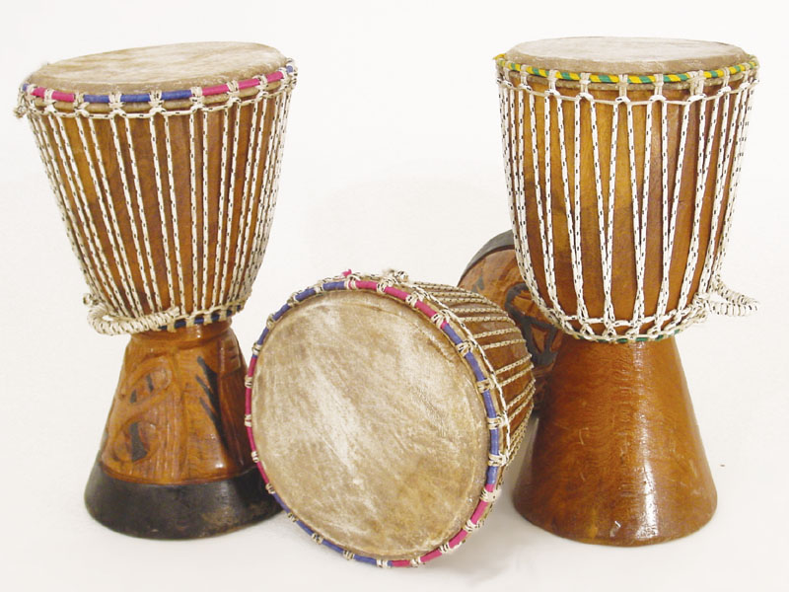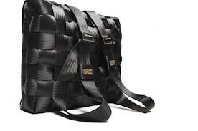
Drums shoes bag

Exercise
- How are poachers a problem to wildlife?
- Mention two uses of wild animals to people.
- Draw any two examples of things made out of skins and hides

WEEK 3
Lesson 1
BIRDS
1. There are two types of birds namely;
- Domestic birds
- Wild birds

2. Domestic birds
These are birds kept in people’s homes.

3. Examples of domestic birds are;
- pigeons
- chicken(cocks, hens and chicks)
- ducks
- turkeys

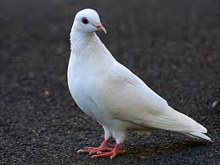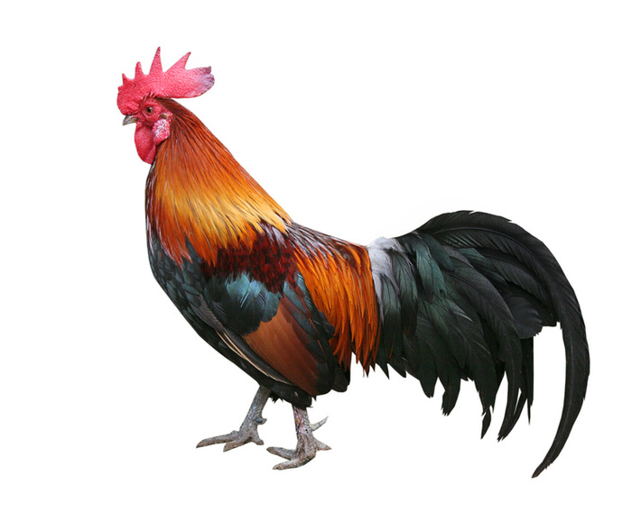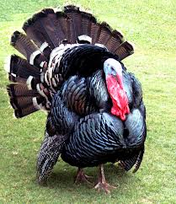
Pigeon cock turkey

4. Uses of domestic birds to people
- They provide eggs, meat, feathers and droppings to people.
- People sell them to get money.(income)
- They are for cultural purposes like sacrifices and paying bride price.

Exercise
- Mention two types of birds.
- Draw, name and colour any two domestic birds.
- State two ways reasons why people rear birds.

Lesson 2
1. Ways of caring for domestic birds:
  - By treating the sick birds.
  - By proper feeding.
  - By providing shelter /habitats.
  - By cleaning their habitats.
  - Being kind to them.
  - By protecting domestic birds from bad people and wild animals.

Exercise
- Suggest any two ways of caring for domestic birds.
- Why should domestic birds be given enough food?

Lesson 3
Wild birds
1. What are wild birds?
These are birds that live in forests, bushes and near water bodies.

2. Examples of wild birds are;

- sun birds
- swallows
- doves
- peacocks
- kites
- parrots
- sparrows
- crested cranes
- eagles
- crows
- marabou storks
- robins

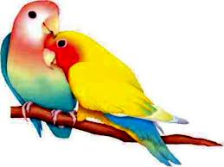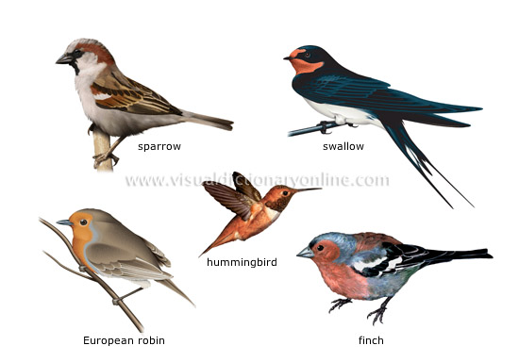
parrots

3. Uses of wild birds to people
- Some provide eggs, meat and feathers.
- They attract tourists.
- Some are domesticated as pets.
- Sun birds help in pollinating plants.
- They are for study purpose.

Exercise
- Name any two wild birds.
- State two ways how wild birds can be useful to us.
- Which wild bird is Uganda’s National Emblem?

Lesson 4
1. Ways of caring for wild birds:
  - By treating the sick birds.
  - By feeding them.
  - Do not shoot stones at them.

2. Dangers of domestic and wild birds
- They destroy people’s crops.
- They make a lot of noise.
- Birds litter our compounds with droppings.
- They spread vectors like fleas.
- Birds spread diseases like bird flu to people.

Exercise
- Suggest any two ways of caring for wild birds.
- Why should domestic birds be given enough food?

Lesson 5&6
DOMESTICATED ANIMALS AND BIRDS

1. What are domesticated animals?
These are wild animals which have been tamed by people.

2. Examples of domesticated animals are;
- monkeys
- buffaloes
- apes
- chimpanzees

3. What are domesticated birds?
These are wild birds which have been tamed by people.

4. Examples of domesticated birds are;
- parrots
- geese
- peacocks
- flamingoes
- doves
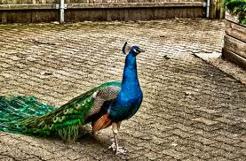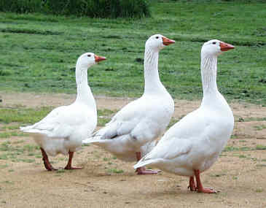
Peacock geese parrots

5. Reasons why people domesticate animals and birds
- They are for pet.
- For meat
- Some birds are for eggs.
- They sell them to get money.

Exercise
- What is the difference between domestic animals and domesticated animals?
- Name any two birds which can be domesticated.
- Why do people domesticate birds like parrots?

Lesson 7

PLANTS
1. Plants grown and cared for by people are called crops.

Types of crops
2. Crops are grouped into;
- Food crops
- Cash crops

Food crops
3. What are food crops?
Food crops are crops grown mainly for food.

4. Examples of food crops include;

- bananas
- rice
- millet
- cassava
- tomatoes

- potatoes
- mangoes
- carrots
- beans

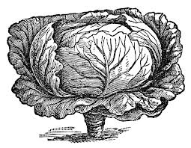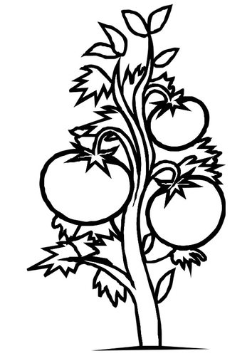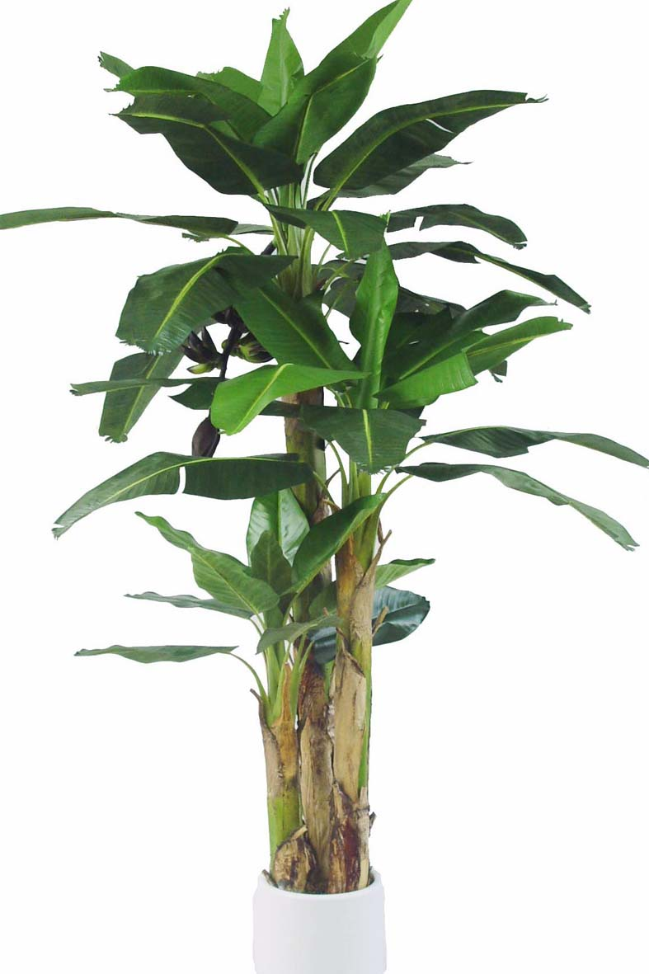

Cabbage tomato banana

Exercise
- Define food crops.
- Draw name and colour any four food crops.
- Apart from getting food, what else do people use food crops for?

WEEK 4
Lesson 1
Cash crops
1. What are cash crops?
Cash crops are crops grown for sale.
2. Examples of cash crops include;

- coffee
- tobacco
- cotton
- tea
- cocoa
- vanilla
- oil palm
- sisal
- sugar canes
- cloves
- pyrethrum
- rubber

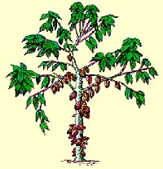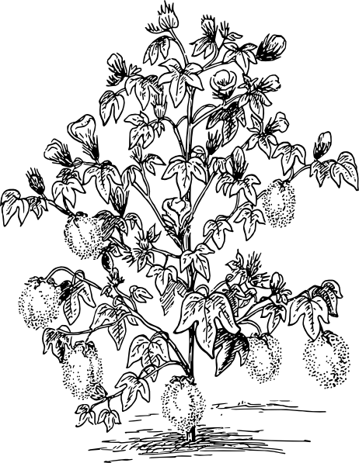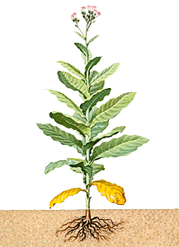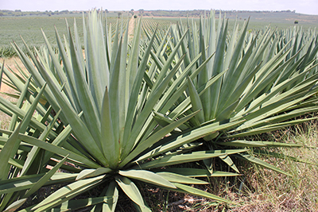
Cocoa cotton tobacco sisal

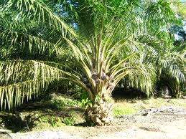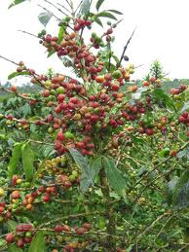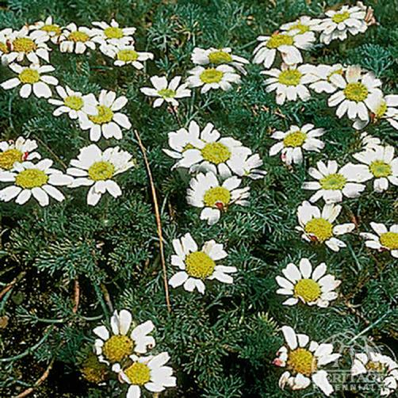
Oil palm coffee pyrethrum

3. Ways of caring for crops
- Weeding and spraying
- Mulching ad staking
- Watering them.
- thinning and pruning
- Controlling crop pests and diseases.
- Harvesting them when they are ready.

Exercise
- Define cash crops.
- Identify any four examples of cash crops.
- State four ways a farmer can care for his crops.
- In which seasons do farmers do these activities?
- Planting crops
- Watering crops
- Harvesting of crops

Lesson 2&3
1. Uses of cash crops
- They are sold to get money.
- Cash crops are used as raw materials for making different products in industries

2. Products got from cash crops

Cash crop | Product(s)
Cotton | - clothes  - threads  - cotton wool  - cooking oil  - soap  - animal cakes
Coffee | - soft drinks(beverages)  - coffee husks  - gun powder
Tea | - beverages
Tobacco | - cigarettes
Cocoa | - beverages  - chocolates  - body jelly(cocoa butter)
Vanilla | - soft drinks(beverages)  - spices
Oil palm | - cooking oil  - soap
Pyrethrum | - insecticides  - perfume
Sugar canes | - sugar  - sweets  - molasses  - animal feeds  - fertilizers
Cloves | - perfumes  - spices
Rubber |  | - tyres  - balloons  - gloves  - rubber bands  - balls  - condoms
Sisal |  | - door mats  - ropes  - sacks  - bags

Exercise
1. What products do people get from the cash crops?

a. sugar cane
b. cotton
c. sisal
d. coffee

2. Which cash crop is needed for making ropes?
3. How can cigarette smoking be dangerous to us?

Lesson 5
TOPICAL TEST
1. How are wild animals different from domestic animals?
2. Give two examples of domestic animals.
3. Write any two birds that are commonly domesticated by people.
4. State any two reasons why some people keep animals in their homes.
5. How can domestic animals be dangerous to us?
6. Where are wild birds and animals kept for people to see?
7. What are cash crops?
8Write any one product got from the following cash crops.

a. tea
b. oil palm
c. vanilla
d. rubber

9. Draw and name two food crops in your areas.

Lesson 6
MANAGING RESOURCES IN OUR SUBCOUNTY
- What is a resource?
A resource is anything used to meet/satisfy people’s needs.
-Some resources are got from living things while others are got from non- living things.

- Basic resources in our environment

- water
- plants
- time
- soil/land
- money
- air
- food
- animals
- fuel
- minerals

Exercise
- What does the word resource mean?
- Name any four basic resources in our surrounding.
- Which resources are used for the following uses?
- Buying other needs
- Growing crops

Lesson 7
WATER
1. Sources of water
1. There are two types of water sources namely:
a. Natural sources
b. Man made sources

a) Natural sources e.g.
- Rain; is the main source of water.

- natural lakes
- swamps
- rivers
- seas
- oceans
- streams

2. Why rain is the main natural source of water?
It gives water to other sources.

b) Man-made sources e.g.

- wells
- boreholes
- protected springs
- ponds
- valley dams

Exercise
- What is the main natural source of water?
- Mention two other natural sources of water.
- Draw and name any two man-made sources of water.

WEEK:5
Lesson 1
Uses of water as a resource
1. Water is used for both domestic (home) and industrial use.

- Domestic uses of water
- Water is used for drinking
- It is used for washing clothes and utensils.
- We use water for mopping houses.

- Industrial uses of water.
- Running water is used to produce hydro- electricity.
- Water is used for making drinks like soda and beer.
- It is used for mixing flour when making bread.
- Water is used to cool engines
- It is used for cleaning utensils in industries.

Exercise
- Write two domestic uses of water.
- State two industrial uses of water.
- Name any one industry that uses water to make drinks.

Lesson 2
FOOD
1. What is food?
Food is anything that people eat or drink.

2. Sources of food
- People get food from;

- gardens
- markets
- supermarkets
- shops
- lakes
- rivers
- animals
- forests

3. Uses of food as a resource:
- We eat food;
-To get energy.
-To build our bodies.
- Food helps our bodies to be healthy.
- Food is sold to get money.

Exercise
- Name two natural sources of food.
- Give two reasons why we eat food.
- Name two classes of food you know.

Lesson 3 &4
FUEL
1. What is fuel?
Fuel is anything burnt to produce heat.

2. Examples of fuel:

- charcoal
- firewood
- paraffin
- coal
- diesel
- electricity
- biogas
- food
- petrol, etc

3. Uses of fuel as a resource:
- Petrol is used in vehicles.
- Firewood and charcoal are used for cooking.
- Food gives us energy in our bodies.

Money
4. Uses of money as resource:
Money is used to buy needs of people like food, school fees, clothes, shelter, etc.

5. Time
Time helps us to plan for all the activities.

Exercise
- What is fuel?
- Identify the fuels needed for the following uses;
- cooking
- lighting
- running vehicles

Lesson 5&6
SAVING RESOURCES
1. What is saving?
It is a way of keeping resources for future use.
-We keep resources e.g food, money, fuel, etc for future use.

2. Ways of saving resources:
- Keeping money in banks or in safe wooden or metallic boxes.
- Preserving food
- Repairing vehicles and furniture.
- Recycling plastics and minerals.
- Planting crops and trees.
- Switching off lights when not in use.
- Using energy saving lights and stoves.
- Proper use of materials
- Budgeting for our money.

3. Reasons why we save:
- We save to avoid wastage.
- We save to meet our needs.
- We save to improve our standards of living.
- We save for future use.

Exercise
- Define the term saving.
- How can the resources be saved?
- money
- electricity
- forests
- Why do people save resources?

Lesson 7
1. Keeping records:
This is the way of keeping information on how resources are used.

2. Examples of records kept.
- Income records
- Bank slips
- Water and electricity bills
- Project records etc

3. Reasons for keeping records:
- To tell how much is spent and saved.
- To know the income.
- To know how much is needed in a family or school.
- To compare the previous expenditure with the present.
- For future reference.

Exercise
- Name ay two records that can be kept at home.
- Give two reasons why record keeping is important on any business.

WEEK;6
Lesson 1 &2
1. Spending resources:
This is the way of using resources to meet our needs.

2. Things we use and spend on:

- food
- cars
- clothes
- time
- fuel
- school fees
- water
- house rent
- electricity
- medicine
- bedding
- building
- furniture

3. Ways of spending wisely:

- budgeting
- negotiating
- prioritizing
- making a work plan
- comparing quality
- making a price list
- comparing prices

4. Why need to spend resources wisely
- To avoid wastage
- To save for the future

Exercise
- Identify any three ways people spend money.
- How can we can we spend our money wisely? Give 4.
- Why do you think we need to spend our money wisely?

Lesson 3&4

Projects
1. What is a project?
A project is an activity done to get knowledge, skills and money.

2. Examples of projects:

- bee keeping
- craft making
- fish farming
- vegetable growing
- cattle rearing
- poultry keeping
- tree planting
- brick making, etc.

3. Things needed to begin a project

- money/ capital
- time
- space/land
- knowledge/skills
- labour

4. Ways of managing a project
- Being committed
- Recording and keeping records.
- Being patient.
- Checking on the project

Exercise
- Define a project.
- Mention any three examples of projects one can do.
- State any two requirements for stating a project.
- How can one manage his/her project well?

Lesson 5
THEME: KEEPING PEACE IN OUR SUB-COUNTY/DIVISION

Living in peace with others
1. What is peace?
Peace is a state when there is no war or violence in an area.

Indicators of peace
2. What shows that people living in an area are peaceful?
- Co-operation
- Respect of one another
- Observing the laws
- Respect of human rights
- Having no quarrels
- No theft
- Having no fights

Exercise
- What is peace?
- Mention any four things which show that there is peace in an area.

Lesson 6&7
1. Causes of insecurity in an area

- theft
- wars
- poverty
- moral decay
- tribal and family conflicts
- lack of trust for each other
- strikes
- unemployment
- disrespect

2. Ways of living in peace
- Observing rules and regulations
- Respecting one another
- Knowing and respecting our differences like lameness
- Praying for one another
- Following good religious teachings
- Respecting human rights
- Working together
- Helping one another in times of trouble

3. Importance of living in peace
- Peace promotes development.
- It brings trust among people.
- It brings happiness among people.

Exercise
- Mention any two causes of insecurity in an area.
- Identify any three ways of living peaceful in school.
- Why do we need to live at peace with everybody?

WEEK: 7
Lesson 1
CHILDREN’S RIGHTS
1. Who is a child?
A child is anybody below eighteen (18) years of age.

2. What are children’s rights?
- These are freedoms of children.
- These are freedoms that all children must enjoy.

3. These rights must be respected by parents and all adults.

4. Examples of children’s rights
- A right to education.
- A right to live.
- A right to medical care.
- A right to equal treatment.
- A right to belong to a clan/family.
- A right to be loved.
- A right to talk freely but with respect.
- A right to food, shelter and clothing.
- A right to have a name.
- A right to know one’s parents.

Exercise
- At what age does one stop being a child in Uganda?
- What are children’s rights?
- Identify any three rights of a child.

Lesson 2
1. People who protect children’s rights
- police
- judges/lawyers
- local council members
- parents
2. Which LC 1 member is in charge of children’s rights?
- The Vice chairperson

3. The National Council for Children (NCC) oversees that children’s rights are observed in Uganda.

4. Importance of children’s rights
- They protect children’s interests.
- They help children to grow healthy i.e. physically and mentally.
- They protect children from any danger.
- They also help grow confidently.
- They are used to pass judgment to a person who violates them.

Exercise
- To which LC member does a child who is abused at home report?
- Write NCC in full.
- Why should people respect children’s rights?

Lesson 3&4

Child abuse
- What is child abuse?
  - Child abuse is the violation of children’s rights.
  - Child abuse is the mistreating of children adults.

- Common forms /types of child abuse
- Physical abuse
- Sexual abuse
- Mental abuse
- Child neglect

- Physical abuse
-This involves putting injuries or pain to a child e.g.
- burning children
- child labour
- child battering
- child sacrifice

- Sexual abuse
-This includes all sexual mistreatment e.g.
- defilement
- early marriage
- bad touches
- oral kisses
- Abuse of obscene words

Exercise
- What is child abuse?
- Identify any two types of child abuse.
- Name ay two sexual forms of child abuse.

Lesson:5
c) Mental /Psychological/ Emotional abuse
-This involves torturing the child’s mind e.g.

- bullying
- harassing a child
- intimidating (threatening )

d) Child neglect
Is when parents fail to provide basic needs to their children e.g.
- denial of clothes
- denial of shelter
- denial of education
- denial of food

People who abuse children’s rights

- some teachers
- some parents
- some relatives
- witch doctors
- peers and siblings
- some maids

- mentally disturbed people e.g. drug addicts.

Exercise
Identify any two forms of child neglect.
Mention any two groups of people who abuse children.
Draw; name and colour any two needs of a child.

Lesson 6
Causes of child abuse
- poverty;
When there is no money in the family, children do not get basic needs.
- Alcoholism;
Some drunken parents burn, beat and lock out children.
- Broken/divorced families;
When parents separate, children are at times mistreated by step-parents.
- Death of both parents ;
When parents die, children are left as orphans without any one to take care of them.
- Wars;
When parents die in wars, children end up on the streets for survival.
- Indiscipline among children;
Some children misbehave and when they are punished, they run from their homes and end up on streets.
- Ignorance;
Some people mistreat children because they do not know about children’s rights.

Exercise
- Outline three causes of child abuse at home.
- How do children lead to abuse of their own rights?
- Name any two causes of street children in Kampala.

Lesson 7
Ways of controlling child abuse
- Parents should avoid alcoholism.
- Adults should be taught about children’s rights.
- Teaching children their rights and responsibilities.
- Parents should work hard to provide needs for their children.
- Teaching good morals/ discipline in society.
- Imprisoning people who abuse rights of children.
- Discouraging divorce/ separation of parents.
- Resettling orphans and street children.

NB: Children who commit offences are taken to juvenile courts for advice and reformation.

Exercise
- Suggest three ways of controlling child abuse in Uganda.
- How are juvenile courts important in a place?

WEEK 8
Lesson 1
Children’s responsibilities/duties /obligations
- In a family/home;
- Children should obey their parents.
- Fetching water.
- Washing utensils and clothes.
- Mopping the house.
- Sweeping the compound
- Collecting fire wood.
- Cooking food.
- Respecting their parents.
- Protecting their families.
- Children should support their parents when they grow up.
- Taking care of family property.
- Contributing to the economic development of the families.

Exercise
- State four ways children can help their parents at home.
- Draw and name any two basic needs of a family.

Lesson 2
- Responsibility of children at school;
- Respecting prefects, teachers and fellow pupils.
- Obeying school rules and regulations.
- Cleaning the class.
- Cleaning the compound.
- Caring for school property.
- Participating in class and school activities.
- Electing leaders like prefects monitors etc.

Exercise
- State any three duties of children at school.
- How can we keep our class clean?
- Draw, name and colour any two things we use to clean our class.

Lesson 3
- Responsibility of children in the country/community;
- Respecting the laws of their country.
- Having love for one’s country (patriotism)
- Contributing to the development of one’s country.
- Respecting the leaders.

Qn. How can children help support their families?
- Children sell in shops.
- Some children hawk goods.
- Some children serve as maids in other people’s homes.

Exercise
- What is the name of our country?
- Who is the president of our country?
- Identify one responsibility of children in community.

Lesson 4
Topical test
- What are children’s rights?
- Identify any four examples of children’s rights.
- Suggest one importance of children’s rights.
- Who is responsible for children’s rights on the Local Council committee?
- Name the place where children who commit offences are taken for advice.
- What is child abuse?
- Write down any two causes of child abuse.
- Mention three examples of child abuse practices.
- Suggest two ways of controlling child abuse.
- Identify two responsibilities of children ;
- At home
- At school
- In the country/community
11. Suggest any two ways we can live peacefully.
12. Mention any two causes of insecurity.
13. State any three signs of insecurity in an area

THE END

